Search

Searched the New Zealand store for “gay” in iPhone Apps.

* [All](https://fnd.io/#/nz/search?mediaType=all&term=gay)
* [Apps](https://fnd.io/#/nz/search?mediaType=ios&term=gay)
* [Music](https://fnd.io/#/nz/search?mediaType=music&term=gay)
* [Movies](https://fnd.io/#/nz/search?mediaType=movies&term=gay)
* [Books](https://fnd.io/#/nz/search?mediaType=books&term=gay)
* [Mac](https://fnd.io/#/nz/search?mediaType=mac&term=gay)
* [Podcasts](https://fnd.io/#/nz/search?mediaType=podcasting&term=gay)
  + [Books](https://fnd.io/#/nz/search?mediaType=books&term=gay)
  + [Mac](https://fnd.io/#/nz/search?mediaType=mac&term=gay)
  + [Podcasts](https://fnd.io/#/nz/search?mediaType=podcasting&term=gay)

[All](https://fnd.io/#/nz/search?mediaType=ios&term=gay) [iPhone](https://fnd.io/#/nz/search?mediaType=iphone&term=gay) [iPad](https://fnd.io/#/nz/search?mediaType=ipad&term=gay) [Developers](https://fnd.io/#/nz/search?mediaType=software-developer&term=gay)

* [SCRUFF](https://fnd.io/#/nz/ios-universal-app/380015247-scruff-by-perry-street-software-inc)  
  Social Networking  
  (221)  
  [Free](https://apps.apple.com/nz/app/scruff/id380015247?uo=4&at=11l6hc&app=itunes&ct=fnd)
  + 
  + 
  + 
  + 
  + 
  + 
  + 
* [Daddyhunt: Fun Gay Dating](https://fnd.io/#/nz/ios-universal-app/921687947-daddyhunt-fun-gay-dating-by-dh-services)  
  Social Networking  
  (13)  
  [Free](https://apps.apple.com/nz/app/daddyhunt-fun-gay-dating/id921687947?uo=4&at=11l6hc&app=itunes&ct=fnd)
  + 
  + 
  + 
* [Blued - Gay Chat & Gay Dating](https://fnd.io/#/nz/iphone-app/1090274263-blued-gay-chat-gay-dating-by-bluecity-ho)  
  Social Networking  
  (25)  
  [Free](https://apps.apple.com/nz/app/blued-gay-chat-gay-dating/id1090274263?uo=4&at=11l6hc&app=itunes&ct=fnd)
  + 
  + 
  + 
  + 
* [SURGE – Gay Dating & Chat App](https://fnd.io/#/nz/ios-universal-app/709551897-surge-gay-dating-chat-app-by-surge-gay-ap)  
  Lifestyle  
  (90)  
  [Free](https://apps.apple.com/nz/app/surge-gay-dating-chat-app/id709551897?uo=4&at=11l6hc&app=itunes&ct=fnd)
  + 
  + 
  + 
  + 
  + 
  + 
  + 
* [Jack’d - Gay Chat & Dating](https://fnd.io/#/nz/ios-universal-app/350426804-jackd-gay-chat-dating-by-perry-street-sof)  
  Social Networking  
  (5)  
  [Free](https://apps.apple.com/nz/app/jackd-gay-chat-dating/id350426804?uo=4&at=11l6hc&app=itunes&ct=fnd)
  + 
  + 
  + 
  + 
  + 
* [Grindr - Gay chat](https://fnd.io/#/nz/ios-universal-app/319881193-grindr-gay-chat-by-grindr-llc)  
  Social Networking  
  (156)  
  [Free](https://apps.apple.com/nz/app/grindr-gay-chat/id319881193?uo=4&at=11l6hc&app=itunes&ct=fnd)
  + 
  + 
  + 
  + 
* [Bumble - Dating. Friends. Chat](https://fnd.io/#/nz/iphone-app/930441707-bumble-dating-friends-chat-by-bumble-hold)  
  Lifestyle  
  (11,697)  
  [Free](https://apps.apple.com/nz/app/bumble-dating-friends-chat/id930441707?uo=4&at=11l6hc&app=itunes&ct=fnd)
  + 
  + 
  + 
  + 
  + 
  + 
  + 
  + 
  + 
* [Tinder - Dating. Friends. Fun.](https://fnd.io/#/nz/iphone-app/547702041-tinder-dating-friends-fun-by-tinder-inc)  
  Lifestyle  
  (2,118)  
  [Free](https://apps.apple.com/nz/app/tinder-dating-friends-fun/id547702041?uo=4&at=11l6hc&app=itunes&ct=fnd)
  + 
  + 
  + 
  + 
  + 
* [Taimi: LGBTQ+ Dating, Chat](https://fnd.io/#/nz/ios-universal-app/1282966364-taimi-lgbtq-dating-chat-by-social-impact)  
  Social Networking  
  (654)  
  [Free](https://apps.apple.com/nz/app/taimi-lgbtq-dating-chat/id1282966364?uo=4&at=11l6hc&app=itunes&ct=fnd)
  + 
  + 
  + 
  + 
  + 
  + 
* [gay dating- VGL twinks & jocks](https://fnd.io/#/nz/ios-universal-app/602776294-gay-dating-vgl-twinks-jocks-by-byte-facto)  
  Social Networking  
  (3)  
  [Free](https://apps.apple.com/nz/app/gay-dating-vgl-twinks-jocks/id602776294?uo=4&at=11l6hc&app=itunes&ct=fnd)
  + 
  + 
  + 
  + 
* [HOLE, the gay chat & dating](https://fnd.io/#/nz/iphone-app/1154947579-hole-the-gay-chat-dating-by-soul-technol)  
  Social Networking  
  (3)  
  [Free](https://apps.apple.com/nz/app/hole-the-gay-chat-dating/id1154947579?uo=4&at=11l6hc&app=itunes&ct=fnd)
  + 
  + 
  + 
  + 
  + 
* [Krave- Gay Chat, Gay Dating](https://fnd.io/#/nz/ios-universal-app/543845489-krave-gay-chat-gay-dating-by-hiball-llc)  
  Social Networking  
  [Free](https://apps.apple.com/nz/app/krave-gay-chat-gay-dating/id543845489?uo=4&at=11l6hc&app=itunes&ct=fnd)
  + 
  + 
  + 
  + 
  + 
* [Adam4Adam Gay Dating Chat A4A](https://fnd.io/#/nz/ios-universal-app/440185993-adam4adam-gay-dating-chat-a4a-by-a4a-netw)  
  Social Networking  
  (4)  
  [Free](https://apps.apple.com/nz/app/adam4adam-gay-dating-chat-a4a/id440185993?uo=4&at=11l6hc&app=itunes&ct=fnd)
  + 
  + 
  + 
  + 
  + 
* [Badoo — Dating. Chat. Friends](https://fnd.io/#/nz/ios-universal-app/351331194-badoo-dating-chat-friends-by-badoo-softwa)  
  Lifestyle  
  (851)  
  [Free](https://apps.apple.com/nz/app/badoo-dating-chat-friends/id351331194?uo=4&at=11l6hc&app=itunes&ct=fnd)
  + 
  + 
  + 
  + 
  + 
  + 
* [ROMEO - Gay Dating & Chat](https://fnd.io/#/nz/ios-universal-app/404386888-romeo-gay-dating-chat-by-planetromeo-bv)  
  Social Networking  
  (106)  
  [Free](https://apps.apple.com/nz/app/romeo-gay-dating-chat/id404386888?uo=4&at=11l6hc&app=itunes&ct=fnd)
  + 
  + 
  + 
  + 
  + 
  + 
  + 
  + 
* [3Fun: Threesome & Swingers App](https://fnd.io/#/nz/ios-universal-app/1164067996-3fun-threesome-swingers-app-by-3fun-limi)  
  Social Networking  
  (152)  
  [Free](https://apps.apple.com/nz/app/3fun-threesome-swingers-app/id1164067996?uo=4&at=11l6hc&app=itunes&ct=fnd)
  + 
  + 
  + 
  + 
  + 
* [Getmale Gay Dating](https://fnd.io/#/nz/ios-universal-app/609004876-getmale-gay-dating-by-kozelo)  
  Social Networking  
  [Free](https://apps.apple.com/nz/app/getmale-gay-dating/id609004876?uo=4&at=11l6hc&app=itunes&ct=fnd)
  + 
  + 
  + 
* [Gay Dating Hookup Chat App for Kik & Snapchat](https://fnd.io/#/nz/ios-universal-app/1166888457-gay-dating-hookup-chat-app-for-kik-snapc)  
  Social Networking  
  [Free](https://apps.apple.com/nz/app/gay-dating-hookup-chat-app-for-kik-snapchat/id1166888457?uo=4&at=11l6hc&app=itunes&ct=fnd)
  + 
  + 
  + 
  + 
* [Zoosk Dating: Chat, Meet, Date](https://fnd.io/#/nz/ios-universal-app/349160522-zoosk-dating-chat-meet-date-by-zoosk-inc)  
  Social Networking  
  (424)  
  [Free](https://apps.apple.com/nz/app/zoosk-dating-chat-meet-date/id349160522?uo=4&at=11l6hc&app=itunes&ct=fnd)
  + 
  + 
  + 
  + 
  + 
  + 
  + 
  + 
* [Cruising gay hangouts](https://fnd.io/#/nz/iphone-app/1023671750-cruising-gay-hangouts-by-samuel-hervas-g)  
  Social Networking  
  [Free](https://apps.apple.com/nz/app/cruising-gay-hangouts/id1023671750?uo=4&at=11l6hc&app=itunes&ct=fnd)
  + 
  + 
  + 
* [GROWLr: Gay Bears Near You](https://fnd.io/#/nz/ios-universal-app/393402212-growlr-gay-bears-near-you-by-initech-llc)  
  Social Networking  
  (183)  
  [Free](https://apps.apple.com/nz/app/growlr-gay-bears-near-you/id393402212?uo=4&at=11l6hc&app=itunes&ct=fnd)
  + 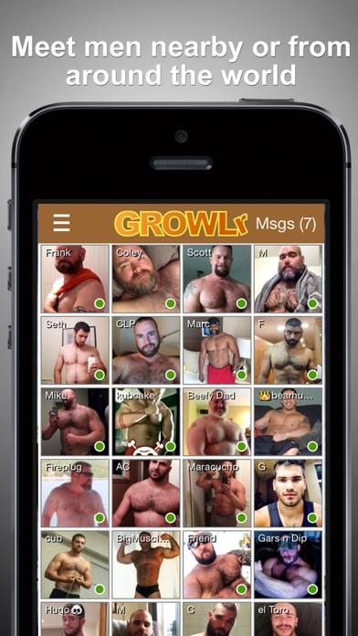
  + 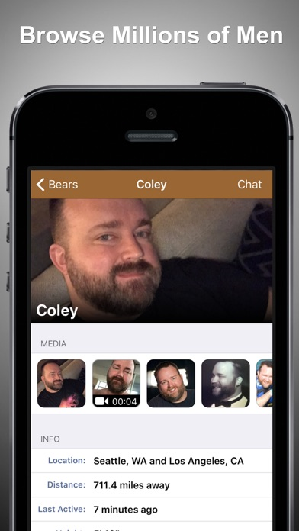
  + 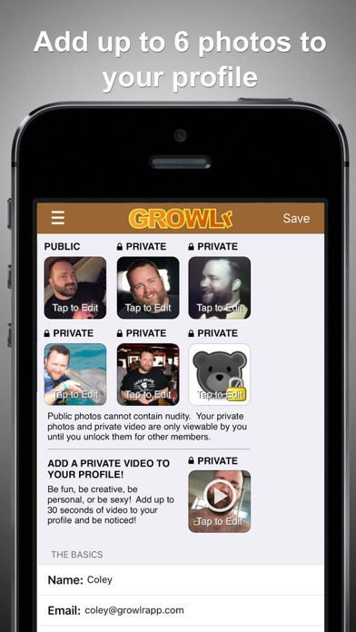
  + 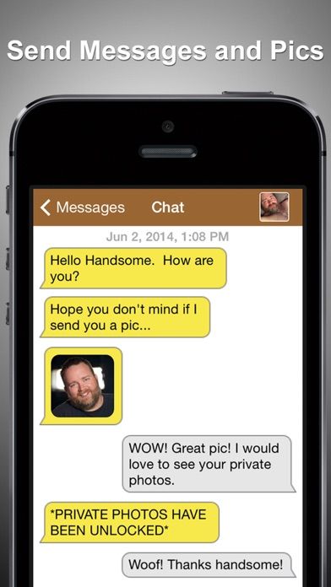
  + 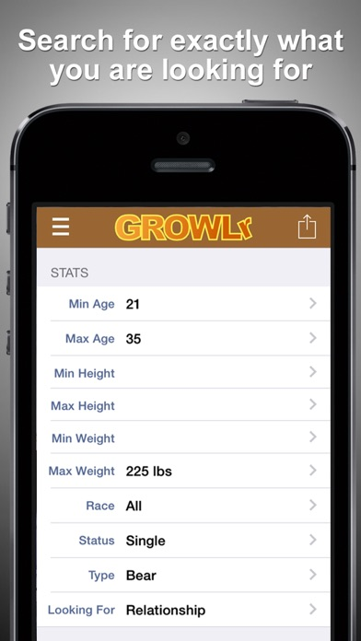
* [Gays AroundMe - Gay Dating To Meet New Local Guys](https://fnd.io/#/nz/ios-universal-app/476454059-gays-aroundme-gay-dating-to-meet-new-loca)  
  Social Networking  
  (2)  
  [Free](https://apps.apple.com/nz/app/gays-aroundme-gay-dating-to-meet-new-local-guys/id476454059?uo=4&at=11l6hc&app=itunes&ct=fnd)
  + 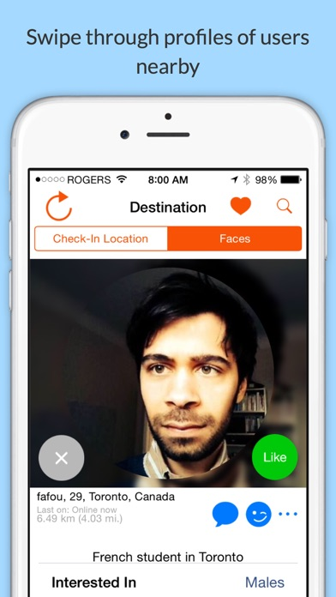
  + 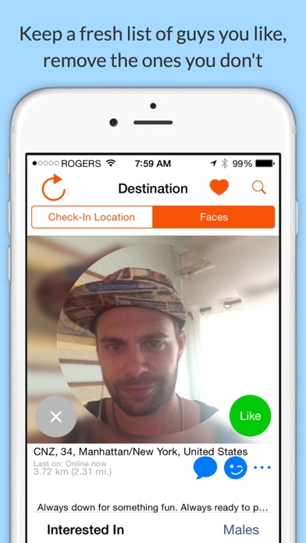
  + 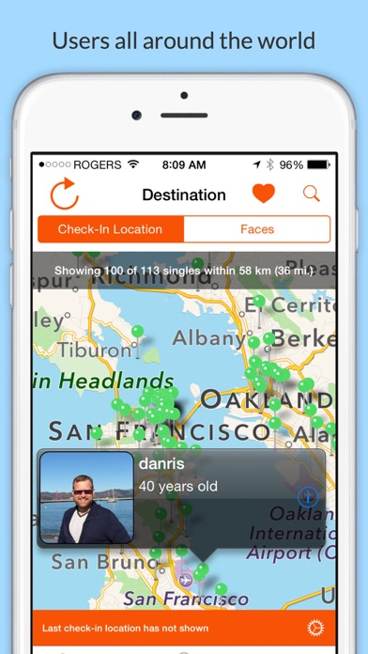
  + 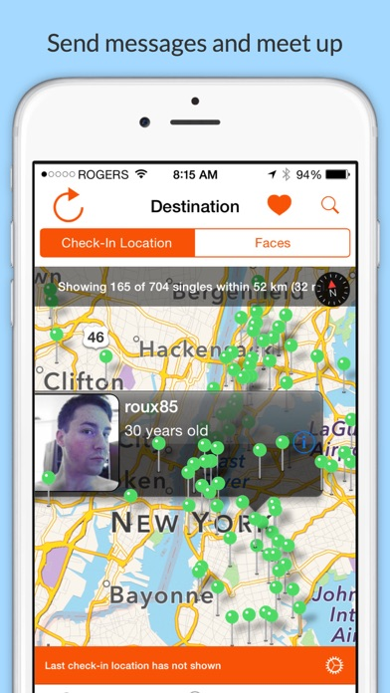
  + 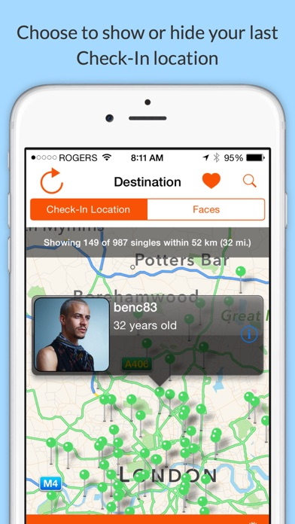
* [OkCupid: Online Dating App](https://fnd.io/#/nz/iphone-app/338701294-okcupid-online-dating-app-by-okcupid)  
  Social Networking  
  (285)  
  [Free](https://apps.apple.com/nz/app/okcupid-online-dating-app/id338701294?uo=4&at=11l6hc&app=itunes&ct=fnd)
  + 
  + 
  + 
  + 
  + 
  + 
* [Mr X: Gay chat and dating](https://fnd.io/#/nz/ios-universal-app/429431089-mr-x-gay-chat-and-dating-by-dh-services)  
  Social Networking  
  (5)  
  [Free](https://apps.apple.com/nz/app/mr-x-gay-chat-and-dating/id429431089?uo=4&at=11l6hc&app=itunes&ct=fnd)
  + 
  + 
  + 
* [Skout — Meet New People](https://fnd.io/#/nz/ios-universal-app/302324249-skout-meet-new-people-by-skout-inc)  
  Social Networking  
  (1,480)  
  [Free](https://apps.apple.com/nz/app/skout-meet-new-people/id302324249?uo=4&at=11l6hc&app=itunes&ct=fnd)
  + 
  + 
  + 
  + 
* [Clover Dating App](https://fnd.io/#/nz/iphone-app/771990977-clover-dating-app-by-clover-inc)  
  Social Networking  
  (190)  
  [Free](https://apps.apple.com/nz/app/clover-dating-app/id771990977?uo=4&at=11l6hc&app=itunes&ct=fnd)
  + 
  + 
  + 
  + 
  + 
  + 
  + 
  + 
  + 
  + 
* [Hornet - Gay Social Network](https://fnd.io/#/nz/ios-universal-app/462678375-hornet-gay-social-network-by-hornet-netwo)  
  Social Networking  
  (28)  
  [Free](https://apps.apple.com/nz/app/hornet-gay-social-network/id462678375?uo=4&at=11l6hc&app=itunes&ct=fnd)
  + 
  + 
  + 
  + 
  + 
  + 
  + 
  + 
* [GuySpy: Gay Dating & Chat](https://fnd.io/#/nz/iphone-app/1185069140-guyspy-gay-dating-chat-by-pink-triangle-)  
  Social Networking  
  (59)  
  [Free](https://apps.apple.com/nz/app/guyspy-gay-dating-chat/id1185069140?uo=4&at=11l6hc&app=itunes&ct=fnd)
  + 
  + 
  + 
  + 
  + 
  + 
  + 
  + 
  + 
* [Gaydar - Gay Dating and Chat](https://fnd.io/#/nz/ios-universal-app/371711798-gaydar-gay-dating-and-chat-by-cpc-connect)  
  Social Networking  
  (1)  
  [Free](https://apps.apple.com/nz/app/gaydar-gay-dating-and-chat/id371711798?uo=4&at=11l6hc&app=itunes&ct=fnd)
  + 
  + 
  + 
  + 
  + 
  + 
* [Gay Dating Hookup App - GKiss](https://fnd.io/#/nz/iphone-app/1491358253-gay-dating-hookup-app-gkiss-by)  
  Social Networking  
  [Free](https://apps.apple.com/nz/app/gay-dating-hookup-app-gkiss/id1491358253?uo=4&at=11l6hc&app=itunes&ct=fnd)
  + 
  + 
  + 
  + 
  + 
* [HER: Lesbian & LGBTQ Dating](https://fnd.io/#/nz/ios-universal-app/573328837-her-lesbian-lgbtq-dating-by-bloomer-inc)  
  Lifestyle  
  (144)  
  [Free](https://apps.apple.com/nz/app/her-lesbian-lgbtq-dating/id573328837?uo=4&at=11l6hc&app=itunes&ct=fnd)
  + 
  + 
  + 
  + 
  + 
* [DOWN Date&Hookup:18+ Fun Chat](https://fnd.io/#/nz/iphone-app/601174087-down-datehookup18-fun-chat-by-down-inc)  
  Lifestyle  
  (91)  
  [Free](https://apps.apple.com/nz/app/down-date-hookup-18-fun-chat/id601174087?uo=4&at=11l6hc&app=itunes&ct=fnd)
  + 
  + 
  + 
  + 
  + 
  + 
  + 
* [Manhunt – Gay Chat, Meet, Date](https://fnd.io/#/nz/ios-universal-app/398537918-manhunt-gay-chat-meet-date-by-online-budd)  
  Lifestyle  
  (3)  
  [Free](https://apps.apple.com/nz/app/manhunt-gay-chat-meet-date/id398537918?uo=4&at=11l6hc&app=itunes&ct=fnd)
  + 
  + 
  + 
  + 
  + 
* [Tagged -Chill, Chat & Go Live!](https://fnd.io/#/nz/ios-universal-app/358899126-tagged-chill-chat-go-live-by-ifwe-inc)  
  Social Networking  
  (1,378)  
  [Free](https://apps.apple.com/nz/app/tagged-chill-chat-go-live/id358899126?uo=4&at=11l6hc&app=itunes&ct=fnd)
  + 
  + 
  + 
  + 
  + 
  + 
* [My Story: Choose Your Own Path](https://fnd.io/#/nz/ios-universal-app/1128416098-my-story-choose-your-own-path-by-nanobit)  
  Games  
  (640)  
  [Free](https://apps.apple.com/nz/app/my-story-choose-your-own-path/id1128416098?uo=4&at=11l6hc&app=itunes&ct=fnd)
  + 
  + 
  + 
  + 
  + 
* [Video Call Santa](https://fnd.io/#/nz/ios-universal-app/947281623-video-call-santa-by-dualverse-inc)  
  Entertainment  
  (540)  
  [Free](https://apps.apple.com/nz/app/video-call-santa/id947281623?uo=4&at=11l6hc&app=itunes&ct=fnd)
  + 
  + 
  + 
  + 
  + 
  + 
  + 
* [Amino: Communities and Chats](https://fnd.io/#/nz/iphone-app/1115565187-amino-communities-and-chats-by-narvii-in)  
  Social Networking  
  (1,339)  
  [Free](https://apps.apple.com/nz/app/amino-communities-and-chats/id1115565187?uo=4&at=11l6hc&app=itunes&ct=fnd)
  + 
  + 
  + 
  + 
* [MeetMe - Meet new people!](https://fnd.io/#/nz/iphone-app/372648912-meetme-meet-new-people-by-meetme-inc)  
  Social Networking  
  (463)  
  [Free](https://apps.apple.com/nz/app/meetme-meet-new-people/id372648912?uo=4&at=11l6hc&app=itunes&ct=fnd)
  + 
  + 
  + 
  + 
  + 
* [LGBT Dating Seeking: BiOpen](https://fnd.io/#/nz/iphone-app/1471651782-lgbt-dating-seeking-biopen-by-evgeniya-v)  
  Social Networking  
  [Free](https://apps.apple.com/nz/app/lgbt-dating-seeking-biopen/id1471651782?uo=4&at=11l6hc&app=itunes&ct=fnd)
  + 
  + 
  + 
  + 
  + 
  + 
* [EliteSingles - Serious Dating](https://fnd.io/#/nz/ios-universal-app/990571557-elitesingles-serious-dating-by-spark-netw)  
  Social Networking  
  (1,400)  
  [Free](https://apps.apple.com/nz/app/elitesingles-serious-dating/id990571557?uo=4&at=11l6hc&app=itunes&ct=fnd)
  + 
  + 
  + 
  + 
  + 
  + 
* [Video Chat BFF - Social Text Messenger to Match Straight, Gay, Lesbian Singles nearby for FaceTime, Skype, Kik & Snapchat calls](https://fnd.io/#/nz/iphone-app/483508042-video-chat-bff-social-text-messenger-to-m)  
  Social Networking  
  (1)  
  [Free](https://apps.apple.com/nz/app/video-chat-bff-social-text-messenger-to-match-straight/id483508042?uo=4&at=11l6hc&app=itunes&ct=fnd)
  + 
  + 
  + 
  + 
  + 
* [Kinkr: Kink Fetish BDSM Dating](https://fnd.io/#/nz/iphone-app/1485825130-kinkr-kink-fetish-bdsm-dating-by-dating-)  
  Lifestyle  
  [Free](https://apps.apple.com/nz/app/kinkr-kink-fetish-bdsm-dating/id1485825130?uo=4&at=11l6hc&app=itunes&ct=fnd)
  + 
  + 
  + 
  + 
  + 
* [Chat for Strangers, Video Chat](https://fnd.io/#/nz/ios-universal-app/447269854-chat-for-strangers-video-chat-by-funpokes)  
  Social Networking  
  (135)  
  [Free](https://apps.apple.com/nz/app/chat-for-strangers-video-chat/id447269854?uo=4&at=11l6hc&app=itunes&ct=fnd)
  + 
  + 
  + 
  + 
  + 
* [HARDLINE Chat](https://fnd.io/#/nz/iphone-app/483152448-hardline-chat-by-fmg-inc)  
  Social Networking  
  [Free](https://apps.apple.com/nz/app/hardline-chat/id483152448?uo=4&at=11l6hc&app=itunes&ct=fnd)
  + 
  + 
  + 
  + 
  + 
* [Gay.](https://fnd.io/#/nz/ios-universal-app/1462068523-gay-by-digitalmarketer)  
  Social Networking  
  [Free](https://apps.apple.com/nz/app/gay/id1462068523?uo=4&at=11l6hc&app=itunes&ct=fnd)
  + 
  + 
  + 
  + 
* [MUSLapp Gay dating & socialapp](https://fnd.io/#/nz/iphone-app/1241573685-muslapp-gay-dating-socialapp-by-ootem-ad)  
  Social Networking  
  [Free](https://apps.apple.com/nz/app/muslapp-gay-dating-socialapp/id1241573685?uo=4&at=11l6hc&app=itunes&ct=fnd)
  + 
  + 
  + 
  + 
  + 
* [Feeld: For Couples & Singles](https://fnd.io/#/nz/iphone-app/887914690-feeld-for-couples-singles-by-feeld-ltd)  
  Lifestyle  
  (138)  
  [Free](https://apps.apple.com/nz/app/feeld-for-couples-singles/id887914690?uo=4&at=11l6hc&app=itunes&ct=fnd)
  + 
  + 
  + 
  + 
  + 
  + 
* [Musclr - Gay Muscle Dating](https://fnd.io/#/nz/ios-universal-app/969052674-musclr-gay-muscle-dating-by-pocket-bear-l)  
  Social Networking  
  [Free](https://apps.apple.com/nz/app/musclr-gay-muscle-dating/id969052674?uo=4&at=11l6hc&app=itunes&ct=fnd)
  + 
  + 
  + 
  + 
  + 
* [Grizzly- Gay Dating & Chat](https://fnd.io/#/nz/ios-universal-app/1190926783-grizzly-gay-dating-chat-by-surge-gay-app)  
  Lifestyle  
  (9)  
  [Free](https://apps.apple.com/nz/app/grizzly-gay-dating-chat/id1190926783?uo=4&at=11l6hc&app=itunes&ct=fnd)
  + 
  + 
  + 
  + 
  + 
* [Gayzr - Gay Chat & Dating App](https://fnd.io/#/nz/iphone-app/1381419452-gayzr-gay-chat-dating-app-by-olga-gallya)  
  Social Networking  
  (3)  
  [Free](https://apps.apple.com/nz/app/gayzr-gay-chat-dating-app/id1381419452?uo=4&at=11l6hc&app=itunes&ct=fnd)
  + 
  + 
  + 
* [9monsters Gay Chat](https://fnd.io/#/nz/ios-universal-app/451345005-9monsters-gay-chat-by-team-ab)  
  Social Networking  
  [Free](https://apps.apple.com/nz/app/9monsters-gay-chat/id451345005?uo=4&at=11l6hc&app=itunes&ct=fnd)
  + 
  + 
  + 
  + 
  + 
  + 
  + 
* [misterb&b - Gay Travel](https://fnd.io/#/nz/ios-universal-app/731435608-misterbb-gay-travel-by-sfo84-inc)  
  Travel  
  (15)  
  [Free](https://apps.apple.com/nz/app/misterb-b-gay-travel/id731435608?uo=4&at=11l6hc&app=itunes&ct=fnd)
  + 
  + 
  + 
  + 
  + 
  + 
  + 
* [KinkD: Kink, BDSM Dating Chat](https://fnd.io/#/nz/ios-universal-app/1126201375-kinkd-kink-bdsm-dating-chat-by-bdsm-fetl)  
  Social Networking  
  (100)  
  [Free](https://apps.apple.com/nz/app/kinkd-kink-bdsm-dating-chat/id1126201375?uo=4&at=11l6hc&app=itunes&ct=fnd)
  + 
  + 
  + 
  + 
  + 
* [Rumpur: Gay Dating](https://fnd.io/#/nz/iphone-app/1208014378-rumpur-gay-dating-by-rumpurcom-llc)  
  Lifestyle  
  [Free](https://apps.apple.com/nz/app/rumpur-gay-dating/id1208014378?uo=4&at=11l6hc&app=itunes&ct=fnd)
  + 
  + 
  + 
  + 
  + 
* [My Love & Dating Story Choices](https://fnd.io/#/nz/ios-universal-app/1445130938-my-love-dating-story-choices-by-lab-cave)  
  Games  
  (9)  
  [Free](https://apps.apple.com/nz/app/my-love-dating-story-choices/id1445130938?uo=4&at=11l6hc&app=itunes&ct=fnd)
  + 
  + 
  + 
  + 
  + 
  + 
  + 
  + 
* [Beuronline - gay arab chat](https://fnd.io/#/nz/ios-universal-app/827667639-beuronline-gay-arab-chat-by-studio-presse)  
  Social Networking  
  [Free](https://apps.apple.com/nz/app/beuronline-gay-arab-chat/id827667639?uo=4&at=11l6hc&app=itunes&ct=fnd)
  + 
  + 
  + 
  + 
  + 
* [NextBoy - Gay Hookup & Dating](https://fnd.io/#/nz/ios-universal-app/1434161303-nextboy-gay-hookup-dating-by-timm-kent)  
  Social Networking  
  (4)  
  [Free](https://apps.apple.com/nz/app/nextboy-gay-hookup-dating/id1434161303?uo=4&at=11l6hc&app=itunes&ct=fnd)
  + 
  + 
  + 
* [Chatly - gay chat & hookup](https://fnd.io/#/nz/iphone-app/1468643560-chatly-gay-chat-hookup-by-stanislav-rude)  
  Social Networking  
  [Free](https://apps.apple.com/nz/app/chatly-gay-chat-hookup/id1468643560?uo=4&at=11l6hc&app=itunes&ct=fnd)
  + 
  + 
  + 
  + 
  + 
* [Gayhunt : Gay Hookup & Dating](https://fnd.io/#/nz/iphone-app/1500431191-gayhunt-gay-hookup-dating-by-gayhunt-llc)  
  Social Networking  
  (1)  
  [Free](https://apps.apple.com/nz/app/gayhunt-gay-hookup-dating/id1500431191?uo=4&at=11l6hc&app=itunes&ct=fnd)
  + 
  + 
  + 
  + 
* [u2nite - gay chat and dating](https://fnd.io/#/nz/iphone-app/480606667-u2nite-gay-chat-and-dating-by-wildtrolls-)  
  Social Networking  
  [Free](https://apps.apple.com/nz/app/u2nite-gay-chat-and-dating/id480606667?uo=4&at=11l6hc&app=itunes&ct=fnd)
  + 
  + 
  + 
  + 
* [Obey Me! - Anime Otome Sim -](https://fnd.io/#/nz/ios-universal-app/1477167654-obey-me-anime-otome-sim-by-ntt-solmare)  
  Games  
  (110)  
  [Free](https://apps.apple.com/nz/app/obey-me-anime-otome-sim/id1477167654?uo=4&at=11l6hc&app=itunes&ct=fnd)
  + 
  + 
  + 
  + 
  + 
  + 
* [Findle: Gay Dating & Chat App](https://fnd.io/#/nz/iphone-app/1372550606-findle-gay-dating-chat-app-by-ion-danilo)  
  Social Networking  
  [Free](https://apps.apple.com/nz/app/findle-gay-dating-chat-app/id1372550606?uo=4&at=11l6hc&app=itunes&ct=fnd)
  + 
  + 
  + 
  + 
  + 
* [Gay Video Streaming & Dating](https://fnd.io/#/nz/ios-universal-app/1229347669-gay-video-streaming-dating-by-my-top-app)  
  Social Networking  
  (1)  
  [Free](https://apps.apple.com/nz/app/gay-video-streaming-dating/id1229347669?uo=4&at=11l6hc&app=itunes&ct=fnd)
  + 
  + 
  + 
  + 
  + 
  + 
* [AdultChat live video call&chat](https://fnd.io/#/nz/iphone-app/1514347249-adultchat-live-video-callchat-by-wai-chi)  
  Social Networking  
  (1)  
  [Free](https://apps.apple.com/nz/app/adultchat-live-video-call-chat/id1514347249?uo=4&at=11l6hc&app=itunes&ct=fnd)
  + 
  + 
  + 
  + 
* [Connected2.me – Chat & Meet](https://fnd.io/#/nz/iphone-app/832556482-connected2me-chat-meet-by-c2m)  
  Social Networking  
  (141)  
  [Free](https://apps.apple.com/nz/app/connected2-me-chat-meet/id832556482?uo=4&at=11l6hc&app=itunes&ct=fnd)
  + 
  + 
  + 
  + 
  + 
* [Atraf - gay chat & dating app](https://fnd.io/#/nz/iphone-app/383112193-atraf-gay-chat-dating-app-by-cyberserve-l)  
  Social Networking  
  [Free](https://apps.apple.com/nz/app/atraf-gay-chat-dating-app/id383112193?uo=4&at=11l6hc&app=itunes&ct=fnd)
  + 
  + 
  + 
  + 
  + 
* [MagicMirror - Gay Dating App](https://fnd.io/#/nz/iphone-app/1490772094-magicmirror-gay-dating-app-by-friending-)  
  Social Networking  
  [Free](https://apps.apple.com/nz/app/magicmirror-gay-dating-app/id1490772094?uo=4&at=11l6hc&app=itunes&ct=fnd)
  + 
  + 
  + 
  + 
  + 
* [Sexy Game for Couples: Dirty](https://fnd.io/#/nz/ios-universal-app/595642961-sexy-game-for-couples-dirty-by-dobrinka-p)  
  Entertainment  
  (24)  
  [Free](https://apps.apple.com/nz/app/sexy-game-for-couples-dirty/id595642961?uo=4&at=11l6hc&app=itunes&ct=fnd)
  + 
  + 
  + 
  + 
  + 
* [Wapo Gay Dating & Chat For Men](https://fnd.io/#/nz/ios-universal-app/964162797-wapo-gay-dating-chat-for-men-by-wapo-y-wa)  
  Social Networking  
  (1)  
  [Free](https://apps.apple.com/nz/app/wapo-gay-dating-chat-for-men/id964162797?uo=4&at=11l6hc&app=itunes&ct=fnd)
  + 
  + 
  + 
  + 
  + 
* [Brainbuddy: Quit Porn Forever](https://fnd.io/#/nz/ios-universal-app/726780077-brainbuddy-quit-porn-forever-by-appstudio)  
  Health & Fitness  
  (54)  
  [Free](https://apps.apple.com/nz/app/brainbuddy-quit-porn-forever/id726780077?uo=4&at=11l6hc&app=itunes&ct=fnd)
  + 
  + 
  + 
  + 
  + 
  + 
  + 
  + 
  + 
* [Mini Gay Boyfriend](https://fnd.io/#/nz/iphone-app/404445256-mini-gay-boyfriend-by-digicub-ltd)  
  Games  
  (1)  
  [Free](https://apps.apple.com/nz/app/mini-gay-boyfriend/id404445256?uo=4&at=11l6hc&app=itunes&ct=fnd)
  + 
  + 
  + 
  + 
  + 
* [Cupid - Dating, Chat, Flirt](https://fnd.io/#/nz/iphone-app/379268567-cupid-dating-chat-flirt-by-nsi-holdings-l)  
  Lifestyle  
  (1)  
  [Free](https://apps.apple.com/nz/app/cupid-dating-chat-flirt/id379268567?uo=4&at=11l6hc&app=itunes&ct=fnd)
  + 
  + 
  + 
  + 
* [GayRoyal - Dating & Chat](https://fnd.io/#/nz/ios-universal-app/901795746-gayroyal-dating-chat-by-42pixels)  
  Social Networking  
  [Free](https://apps.apple.com/nz/app/gayroyal-dating-chat/id901795746?uo=4&at=11l6hc&app=itunes&ct=fnd)
  + 
  + 
  + 
  + 
  + 
* [Genie — Gay Dating](https://fnd.io/#/nz/iphone-app/1098244626-genie-gay-dating-by-wayd-llc)  
  Lifestyle  
  [Free](https://apps.apple.com/nz/app/genie-gay-dating/id1098244626?uo=4&at=11l6hc&app=itunes&ct=fnd)
  + 
  + 
  + 
  + 
* [u4Bear: Gay bear social](https://fnd.io/#/nz/ios-universal-app/411134419-u4bear-gay-bear-social-by-aplicaciones-y-)  
  Social Networking  
  (1)  
  [Free](https://apps.apple.com/nz/app/u4bear-gay-bear-social/id411134419?uo=4&at=11l6hc&app=itunes&ct=fnd)
  + 
  + 
  + 
* [Threesome Hookup, 3Some Meet](https://fnd.io/#/nz/iphone-app/1215154593-threesome-hookup-3some-meet-by)  
  Social Networking  
  (15)  
  [Free](https://apps.apple.com/nz/app/threesome-hookup-3some-meet/id1215154593?uo=4&at=11l6hc&app=itunes&ct=fnd)
  + 
  + 
  + 
  + 
  + 
* [Zoe: Lesbian Dating & Chat App](https://fnd.io/#/nz/ios-universal-app/1269081011-zoe-lesbian-dating-chat-app-by-surge-gay)  
  Social Networking  
  (44)  
  [Free](https://apps.apple.com/nz/app/zoe-lesbian-dating-chat-app/id1269081011?uo=4&at=11l6hc&app=itunes&ct=fnd)
  + 
  + 
  + 
  + 
  + 
  + 
* [Love Tester - Crush Test Quiz](https://fnd.io/#/nz/ios-universal-app/1234094465-love-tester-crush-test-quiz-by-dh3-games)  
  Games  
  (114)  
  [Free](https://apps.apple.com/nz/app/love-tester-crush-test-quiz/id1234094465?uo=4&at=11l6hc&app=itunes&ct=fnd)
  + 
  + 
  + 
* [Gaylord-gay dating apps & chat](https://fnd.io/#/nz/iphone-app/1550958953-gaylord-gay-dating-apps-chat-by-gaylord-)  
  Social Networking  
  [Free](https://apps.apple.com/nz/app/gaylord-gay-dating-apps-chat/id1550958953?uo=4&at=11l6hc&app=itunes&ct=fnd)
  + 
  + 
  + 
  + 
  + 
* [Fridae - LGBT Asia](https://fnd.io/#/nz/ios-universal-app/400632898-fridae-lgbt-asia-by-fridae-limited)  
  Social Networking  
  (15)  
  [Free](https://apps.apple.com/nz/app/fridae-lgbt-asia/id400632898?uo=4&at=11l6hc&app=itunes&ct=fnd)
  + 
  + 
  + 
  + 
  + 
  + 
* [Twoo - Meet New People](https://fnd.io/#/nz/ios-universal-app/486773266-twoo-meet-new-people-by-massive-media-mat)  
  Social Networking  
  (12)  
  [Free](https://apps.apple.com/nz/app/twoo-meet-new-people/id486773266?uo=4&at=11l6hc&app=itunes&ct=fnd)
  + 
  + 
  + 
  + 
  + 
* [MEOW Gay Boys & Guys Gay Apps](https://fnd.io/#/nz/iphone-app/672151198-meow-gay-boys-guys-gay-apps-by-shag-digit)  
  Lifestyle  
  [Free](https://apps.apple.com/nz/app/meow-gay-boys-guys-gay-apps/id672151198?uo=4&at=11l6hc&app=itunes&ct=fnd)
  + 
  + 
  + 
  + 
  + 
* [Race Arena - Fall Car Battle](https://fnd.io/#/nz/ios-universal-app/1534304970-race-arena-fall-car-battle-by-devgeim)  
  Games  
  (24)  
  [Free](https://apps.apple.com/nz/app/race-arena-fall-car-battle/id1534304970?uo=4&at=11l6hc&app=itunes&ct=fnd)
  + 
  + 
  + 
  + 
  + 
  + 
* [Matcha: Challenge Your Crush](https://fnd.io/#/nz/ios-universal-app/1253690514-matcha-challenge-your-crush-by-diffcat)  
  Social Networking  
  (5)  
  [Free](https://apps.apple.com/nz/app/matcha-challenge-your-crush/id1253690514?uo=4&at=11l6hc&app=itunes&ct=fnd)
  + 
  + 
  + 
  + 
* [Gay Friendly. Dating Chat Meet](https://fnd.io/#/nz/ios-universal-app/1446173888-gay-friendly-dating-chat-meet-by-dabltec)  
  Social Networking  
  (1)  
  [Free](https://apps.apple.com/nz/app/gay-friendly-dating-chat-meet/id1446173888?uo=4&at=11l6hc&app=itunes&ct=fnd)
  + 
  + 
  + 
  + 
  + 
* [Lovelink™- Chapters of Love](https://fnd.io/#/nz/ios-universal-app/1495865619-lovelink-chapters-of-love-by-ludia)  
  Games  
  (99)  
  [Free](https://apps.apple.com/nz/app/lovelink-chapters-of-love/id1495865619?uo=4&at=11l6hc&app=itunes&ct=fnd)
  + 
  + 
  + 
  + 
  + 
  + 
* [BRO: Friends, Dates, and FWBs](https://fnd.io/#/nz/iphone-app/1049979758-bro-friends-dates-and-fwbs-by-brotech-ll)  
  Social Networking  
  (15)  
  [Free](https://apps.apple.com/nz/app/bro-friends-dates-and-fwbs/id1049979758?uo=4&at=11l6hc&app=itunes&ct=fnd)
  + 
  + 
  + 
  + 
  + 
* [Kinkoo: BDSM, Kink, Fet Dating](https://fnd.io/#/nz/ios-universal-app/1394527740-kinkoo-bdsm-kink-fet-dating-by-kinky-dat)  
  Social Networking  
  (29)  
  [Free](https://apps.apple.com/nz/app/kinkoo-bdsm-kink-fet-dating/id1394527740?uo=4&at=11l6hc&app=itunes&ct=fnd)
  + 
  + 
  + 
  + 
  + 
  + 
* [myBOY - Gay Chat & Dating](https://fnd.io/#/nz/iphone-app/1397288915-myboy-gay-chat-dating-by-timm-kent)  
  Social Networking  
  (1)  
  [Free](https://apps.apple.com/nz/app/myboy-gay-chat-dating/id1397288915?uo=4&at=11l6hc&app=itunes&ct=fnd)
  + 
  + 
  + 
  + 
* [AI Virtual Boyfriend — Romance](https://fnd.io/#/nz/ios-universal-app/1003620852-ai-virtual-boyfriend-romance-by-open-tim)  
  Entertainment  
  (8)  
  [Free](https://apps.apple.com/nz/app/ai-virtual-boyfriend-romance/id1003620852?uo=4&at=11l6hc&app=itunes&ct=fnd)
  + 
  + 
  + 
  + 
  + 
* [LongStory](https://fnd.io/#/nz/ios-universal-app/833958016-longstory-by-bloom-digital-media)  
  Games  
  (13)  
  [Free](https://apps.apple.com/nz/app/longstory/id833958016?uo=4&at=11l6hc&app=itunes&ct=fnd)
  + 
  + 
  + 
  + 
  + 
  + 
  + 
* [Transgender Dating Hook up App](https://fnd.io/#/nz/iphone-app/1377472508-transgender-dating-hook-up-app-by)  
  Social Networking  
  (4)  
  [Free](https://apps.apple.com/nz/app/transgender-dating-hook-up-app/id1377472508?uo=4&at=11l6hc&app=itunes&ct=fnd)
  + 
  + 
  + 
  + 
* [WOW Presents Plus](https://fnd.io/#/nz/ios-universal-app/1194749500-wow-presents-plus-by-world-of-wonder-pro)  
  Entertainment  
  (132)  
  [Free](https://apps.apple.com/nz/app/wow-presents-plus/id1194749500?uo=4&at=11l6hc&app=itunes&ct=fnd)
  + 
  + 
  + 
  + 
  + 
* [Gays dating app - Chance](https://fnd.io/#/nz/ios-universal-app/1195844907-gays-dating-app-chance-by-indating)  
  Entertainment  
  (2)  
  [Free](https://apps.apple.com/nz/app/gays-dating-app-chance/id1195844907?uo=4&at=11l6hc&app=itunes&ct=fnd)
  + 
  + 
  + 
  + 
  + 
* [Recon - Find Fetish Men](https://fnd.io/#/nz/iphone-app/346152901-recon-find-fetish-men-by-t101-limited)  
  Social Networking  
  (3)  
  [Free](https://apps.apple.com/nz/app/recon-find-fetish-men/id346152901?uo=4&at=11l6hc&app=itunes&ct=fnd)
  + 
  + 
  + 
  + 
  + 
* [RealMen](https://fnd.io/#/nz/ios-universal-app/1424378966-realmen-by-rm-media-gmbh)  
  Social Networking  
  (2)  
  [Free](https://apps.apple.com/nz/app/realmen/id1424378966?uo=4&at=11l6hc&app=itunes&ct=fnd)
  + 
  + 
  + 
  + 
  + 
* [Color Dating App – Meet Me](https://fnd.io/#/nz/iphone-app/1100827439-color-dating-app-meet-me-by-slidemail-in)  
  Lifestyle  
  (29)  
  [Free](https://apps.apple.com/nz/app/color-dating-app-meet-me/id1100827439?uo=4&at=11l6hc&app=itunes&ct=fnd)
  + 
  + 
  + 
  + 
* [My Virtual Gay Boyfriend Free](https://fnd.io/#/nz/ios-universal-app/1036708053-my-virtual-gay-boyfriend-free-by-wet-pro)  
  Games  
  (1)  
  [Free](https://apps.apple.com/nz/app/my-virtual-gay-boyfriend-free/id1036708053?uo=4&at=11l6hc&app=itunes&ct=fnd)
  + 
  + 
  + 
  + 
  + 
* [Gay dating & chat app | Notabu](https://fnd.io/#/nz/iphone-app/1485018597-gay-dating-chat-app-notabu-by-kirill-ivl)  
  Social Networking  
  [Free](https://apps.apple.com/nz/app/gay-dating-chat-app-notabu/id1485018597?uo=4&at=11l6hc&app=itunes&ct=fnd)
  + 
  + 
  + 
  + 
  + 
  + 
  + 
* [banana - Gay Male Video Chat](https://fnd.io/#/nz/iphone-app/1187641286-banana-gay-male-video-chat-by-vocato-sl)  
  Social Networking  
  (1)  
  [Free](https://apps.apple.com/nz/app/banana-gay-male-video-chat/id1187641286?uo=4&at=11l6hc&app=itunes&ct=fnd)
  + 
  + 
  + 
* [Tser: TS, Transgender Dating](https://fnd.io/#/nz/ios-universal-app/1436679914-tser-ts-transgender-dating-by-dating-app)  
  Social Networking  
  (7)  
  [Free](https://apps.apple.com/nz/app/tser-ts-transgender-dating/id1436679914?uo=4&at=11l6hc&app=itunes&ct=fnd)
  + 
  + 
  + 
* [BC: LGBT & Bisexual Dating App](https://fnd.io/#/nz/iphone-app/1481809362-bc-lgbt-bisexual-dating-app-by-sathish-d)  
  Lifestyle  
  [Free](https://apps.apple.com/nz/app/bc-lgbt-bisexual-dating-app/id1481809362?uo=4&at=11l6hc&app=itunes&ct=fnd)
  + 
  + 
  + 
  + 
  + 
  + 
  + 
* [Travmaga #1 Trans Dating](https://fnd.io/#/nz/ios-universal-app/1031308414-travmaga-1-trans-dating-by-diva)  
  Lifestyle  
  (1)  
  [Free](https://apps.apple.com/nz/app/travmaga-1-trans-dating/id1031308414?uo=4&at=11l6hc&app=itunes&ct=fnd)
  + 
  + 
  + 
  + 
  + 
* [Maleforce - Gay chat](https://fnd.io/#/nz/ios-universal-app/1164955538-maleforce-gay-chat-by-amoja-ltd)  
  Social Networking  
  [Free](https://apps.apple.com/nz/app/maleforce-gay-chat/id1164955538?uo=4&at=11l6hc&app=itunes&ct=fnd)
  + 
  + 
  + 
  + 
* [Xtremboy - gay fetish chat](https://fnd.io/#/nz/ios-universal-app/1188285842-xtremboy-gay-fetish-chat-by-i-planet)  
  Social Networking  
  [Free](https://apps.apple.com/nz/app/xtremboy-gay-fetish-chat/id1188285842?uo=4&at=11l6hc&app=itunes&ct=fnd)
  + 
  + 
  + 
  + 
  + 
  + 
* [Kitty Powers' Matchmaker](https://fnd.io/#/nz/ios-universal-app/893194736-kitty-powers-matchmaker-by-magic-notion)  
  Games  
  (11)  
  [$4.99](https://apps.apple.com/nz/app/kitty-powers-matchmaker/id893194736?uo=4&at=11l6hc&app=itunes&ct=fnd)
  + 
  + 
  + 
  + 
  + 
* [PearUp - Chat & Dating App](https://fnd.io/#/nz/ios-universal-app/1452411595-pearup-chat-dating-app-by-pearup-inc)  
  Social Networking  
  (19)  
  [Free](https://apps.apple.com/nz/app/pearup-chat-dating-app/id1452411595?uo=4&at=11l6hc&app=itunes&ct=fnd)
  + 
  + 
  + 
  + 
  + 
* [Kitty Powers' Speed Date](https://fnd.io/#/nz/ios-universal-app/939750856-kitty-powers-speed-date-by-magic-notion)  
  Games  
  (3)  
  [Free](https://apps.apple.com/nz/app/kitty-powers-speed-date/id939750856?uo=4&at=11l6hc&app=itunes&ct=fnd)
  + 
  + 
  + 
  + 
  + 
* [Looky - celebrity Lookalike](https://fnd.io/#/nz/ios-universal-app/1231602636-looky-celebrity-lookalike-by-who-do-i-lo)  
  Games  
  (74)  
  [Free](https://apps.apple.com/nz/app/looky-celebrity-lookalike/id1231602636?uo=4&at=11l6hc&app=itunes&ct=fnd)
  + 
  + 
  + 
* [there's this girl](https://fnd.io/#/nz/ios-universal-app/1444002032-theres-this-girl-by-angela-he)  
  Games  
  (45)  
  [Free](https://apps.apple.com/nz/app/theres-this-girl/id1444002032?uo=4&at=11l6hc&app=itunes&ct=fnd)
  + 
  + 
  + 
  + 
  + 
* [Sex Dice - Play love games with your beloved](https://fnd.io/#/nz/ios-universal-app/405020858-sex-dice-play-love-games-with-your-belove)  
  Games  
  (1)  
  [Free](https://apps.apple.com/nz/app/sex-dice-play-love-games-with-your-beloved/id405020858?uo=4&at=11l6hc&app=itunes&ct=fnd)
  + 
  + 
  + 
* [GayCities LGBTQ City Guides](https://fnd.io/#/nz/iphone-app/303661699-gaycities-lgbtq-city-guides-by-qdigital-i)  
  Travel  
  [Free](https://apps.apple.com/nz/app/gaycities-lgbtq-city-guides/id303661699?uo=4&at=11l6hc&app=itunes&ct=fnd)
  + 
  + 
  + 
  + 
  + 
* [GAY TIMES](https://fnd.io/#/nz/ios-universal-app/374917341-gay-times-by-gay-times-limited)  
  Lifestyle  
  [Free](https://apps.apple.com/nz/app/gay-times/id374917341?uo=4&at=11l6hc&app=itunes&ct=fnd)
  + 
  + 
  + 
  + 
  + 
  + 
* [Gaydorado](https://fnd.io/#/nz/ios-universal-app/1229960773-gaydorado-by-moga-studios)  
  Games  
  (24)  
  [Free](https://apps.apple.com/nz/app/gaydorado/id1229960773?uo=4&at=11l6hc&app=itunes&ct=fnd)
  + 
  + 
  + 
  + 
  + 
* [Wapa : Lesbian Dating & Chat](https://fnd.io/#/nz/ios-universal-app/964163407-wapa-lesbian-dating-chat-by-wapo-y-wapa-l)  
  Social Networking  
  (4)  
  [Free](https://apps.apple.com/nz/app/wapa-lesbian-dating-chat/id964163407?uo=4&at=11l6hc&app=itunes&ct=fnd)
  + 
  + 
  + 
  + 
  + 
  + 
* [ThaiJoop - Thai Dating](https://fnd.io/#/nz/ios-universal-app/580010244-thaijoop-thai-dating-by-fwends-ltd)  
  Social Networking  
  (2)  
  [Free](https://apps.apple.com/nz/app/thaijoop-thai-dating/id580010244?uo=4&at=11l6hc&app=itunes&ct=fnd)
  + 
  + 
  + 
  + 
  + 
* [Ghost Detector Haunted Radar](https://fnd.io/#/nz/ios-universal-app/1089084515-ghost-detector-haunted-radar-by-talgame)  
  Entertainment  
  (18)  
  [Free](https://apps.apple.com/nz/app/ghost-detector-haunted-radar/id1089084515?uo=4&at=11l6hc&app=itunes&ct=fnd)
  + 
  + 
  + 
  + 
* [WE - Gay Hookup](https://fnd.io/#/nz/iphone-app/1520398445-we-gay-hookup-by-marlin-brandin)  
  Social Networking  
  [Free](https://apps.apple.com/nz/app/we-gay-hookup/id1520398445?uo=4&at=11l6hc&app=itunes&ct=fnd)
  + 
  + 
  + 
* [Adult Hookup App. Dating Chat](https://fnd.io/#/nz/iphone-app/1328695473-adult-hookup-app-dating-chat-by-lemon-co)  
  Lifestyle  
  [Free](https://apps.apple.com/nz/app/adult-hookup-app-dating-chat/id1328695473?uo=4&at=11l6hc&app=itunes&ct=fnd)
  + 
  + 
  + 
  + 
  + 
  + 
  + 
  + 
  + 

That's everything.

119 results.

Didn't find what you were looking for?

Try one of these searches, preloaded with **“gay”**

* [Search Google](https://www.google.com/search?q=gay)

[The three pieces of chalk up there are a menu.](https://fnd.io/#)

×

Drag and Drop

The image will be downloaded